Name: D.Darshan Course code:DSA0602
Reg no:192524117

Class Activity 2: 15.07.2026

Scenario 1:Smart City Air Quality Monitoring.
Python Code:
import pandas as pd
import matplotlib.pyplot as plt

# Read the dataset
data = pd.read_csv("smart_city_air_quality.csv")

# Plot Histogram
plt.figure(figsize=(8,5))
plt.hist(data["PM2_5"], bins=20, color="skyblue", edgecolor="black")

plt.title("Distribution of PM2.5")
plt.xlabel("PM2.5")
plt.ylabel("Frequency")

plt.grid(True)

# Show the graph
plt.show()

Output:
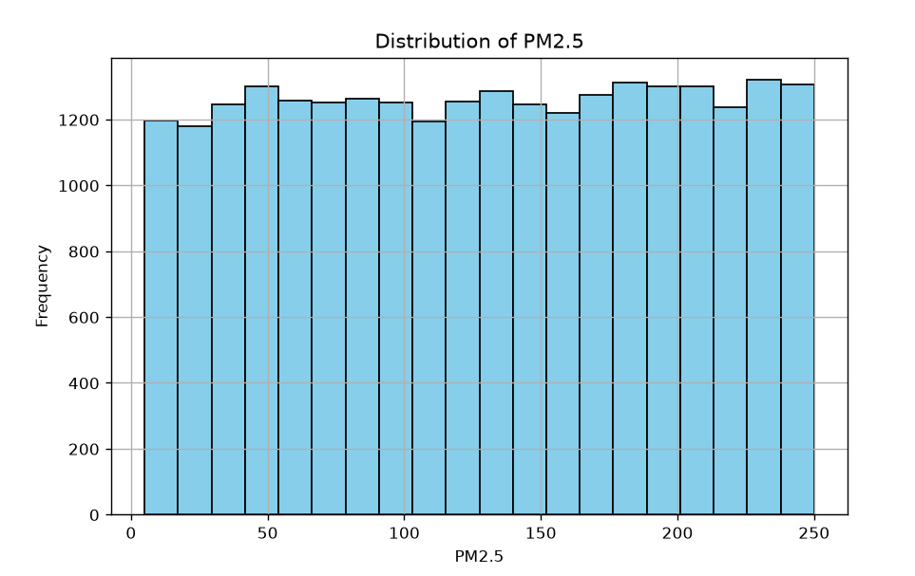

Scenario 2: Earthquake Risk Analysis
Python code:
import pandas as pd
import matplotlib.pyplot as plt

# Read the dataset
data = pd.read_csv("earthquake.csv")

# Create Bubble Chart
plt.figure(figsize=(10,6))

plt.scatter(
data["Longitude"],
data["Latitude"],
s=data["Magnitude"]*50,
c=data["Depth"],
cmap="viridis",
alpha=0.7,
edgecolors="black"
)

# Color bar
plt.colorbar(label="Depth (km)")

# Titles and Labels
plt.title("Earthquake Risk Analysis")
plt.xlabel("Longitude")
plt.ylabel("Latitude")

plt.grid(True)

# Display Graph
plt.show()

Output:
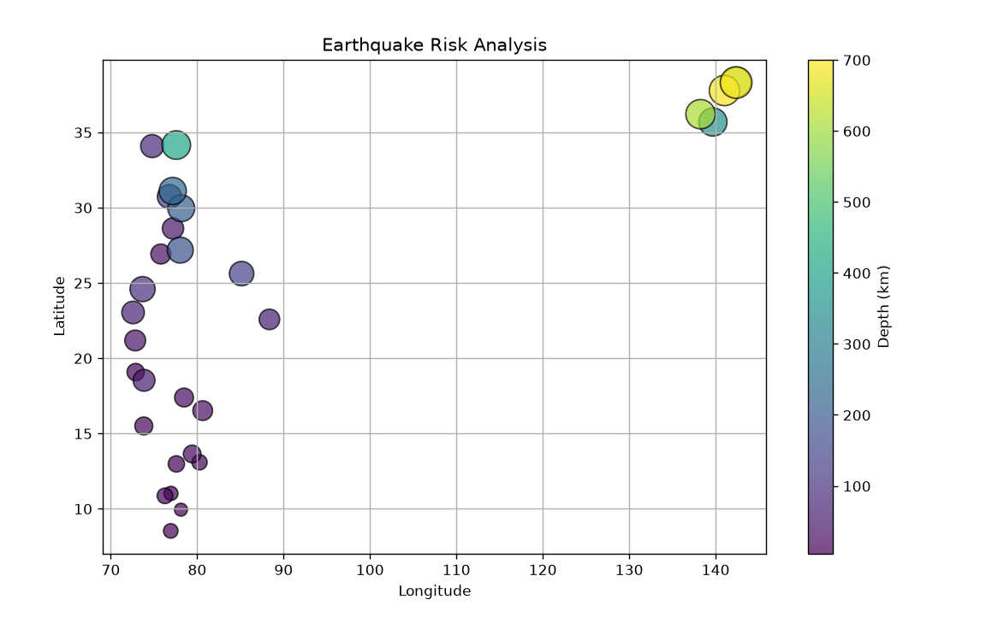

Scenario 3: Wind Direction Analysis for Airport Operations
Python code:
import pandas as pd
import matplotlib.pyplot as plt

# Read dataset
df = pd.read_csv("airport_wind.csv")

# Overall Wind Direction
plt.figure(figsize=(8,5))
plt.scatter(df["Wind_Direction"], df["Wind_Speed_kmh"])
plt.title("Airport Wind Direction Analysis")
plt.xlabel("Wind Direction (Degrees)")
plt.ylabel("Wind Speed (km/h)")
plt.grid(True)
plt.show()

# Seasonal (Monthly) Variation
months = df["Month"].unique()

plt.figure(figsize=(10,6))

for month in months:
data = df[df["Month"] == month]
plt.scatter(data["Wind_Direction"], data["Wind_Speed_kmh"], label=month)

plt.title("Wind Direction by Month")
plt.xlabel("Wind Direction (Degrees)")
plt.ylabel("Wind Speed (km/h)")
plt.legend()
plt.grid(True)
plt.show()

Output:
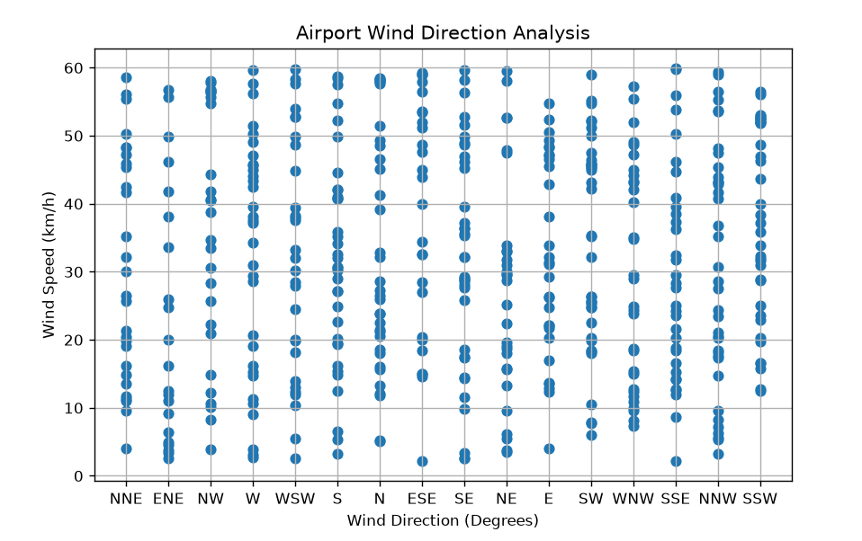

Scenario 4: Hospital Patient Monitoring Dashboard
Python code:
import pandas as pd
import matplotlib.pyplot as plt

# Read dataset
df = pd.read_csv("hospital_patients.csv")

plt.figure(figsize=(12,8))

# Heart Rate
plt.subplot(3,2,1)
plt.plot(df["Heart_Rate_bpm"])
plt.title("Heart Rate")

# Oxygen Saturation
plt.subplot(3,2,2)
plt.plot(df["Oxygen_Saturation_%"])
plt.title("Oxygen Saturation")

# Systolic Blood Pressure
plt.subplot(3,2,3)
plt.plot(df["Systolic_BP"])
plt.title("Systolic BP")

# Diastolic Blood Pressure
plt.subplot(3,2,4)
plt.plot(df["Diastolic_BP"])
plt.title("Diastolic BP")

# Respiration Rate
plt.subplot(3,2,5)
plt.plot(df["Respiration_Rate"])
plt.title("Respiration Rate")

# Temperature
plt.subplot(3,2,6)
plt.plot(df["Temperature_C"])
plt.title("Temperature")

plt.suptitle("Hospital Patient Monitoring Dashboard")
plt.tight_layout()
plt.show()

Output:
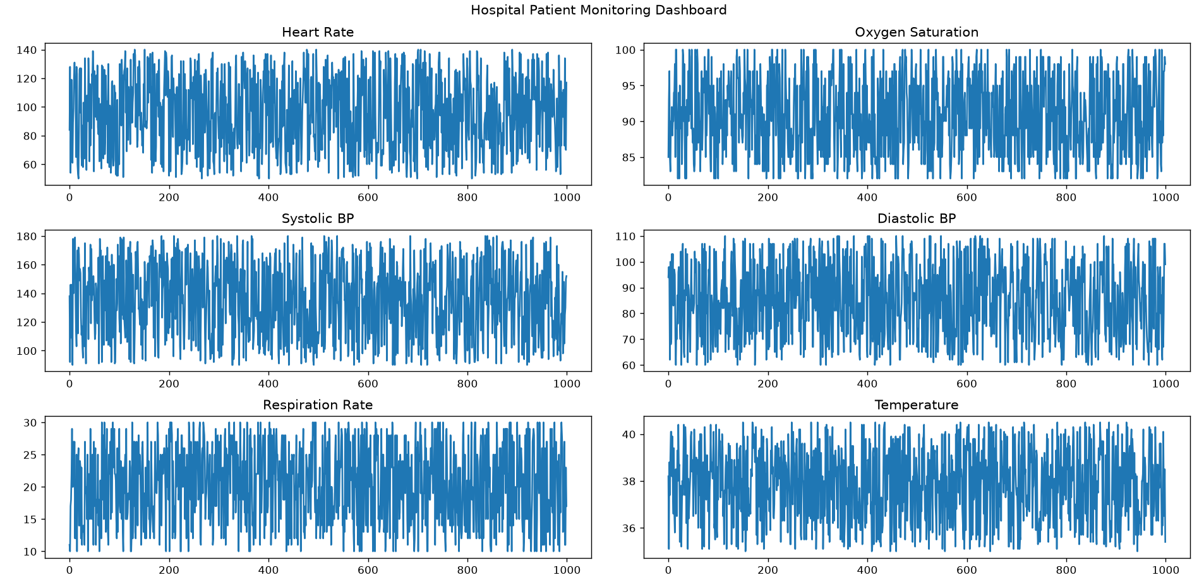

Scenario 5: Global Climate Change Study
Python code:
import pandas as pd
import matplotlib.pyplot as plt

# Read CSV
df = pd.read_csv("global_climate_change.csv")

# Check first 5 rows
print(df.head())

countries = df["Country"]
anomaly = df["Temperature_Anomaly_C"]

# Colors
colors = ["red" if x > 0 else "blue" for x in anomaly]

# Plot
plt.figure(figsize=(10,6))
plt.barh(countries, anomaly, color=colors)
plt.axvline(0, color="black")

plt.title("Global Climate Change (1980–2025)")
plt.xlabel("Temperature Anomaly (°C)")
plt.ylabel("Country")

plt.show()

Output:
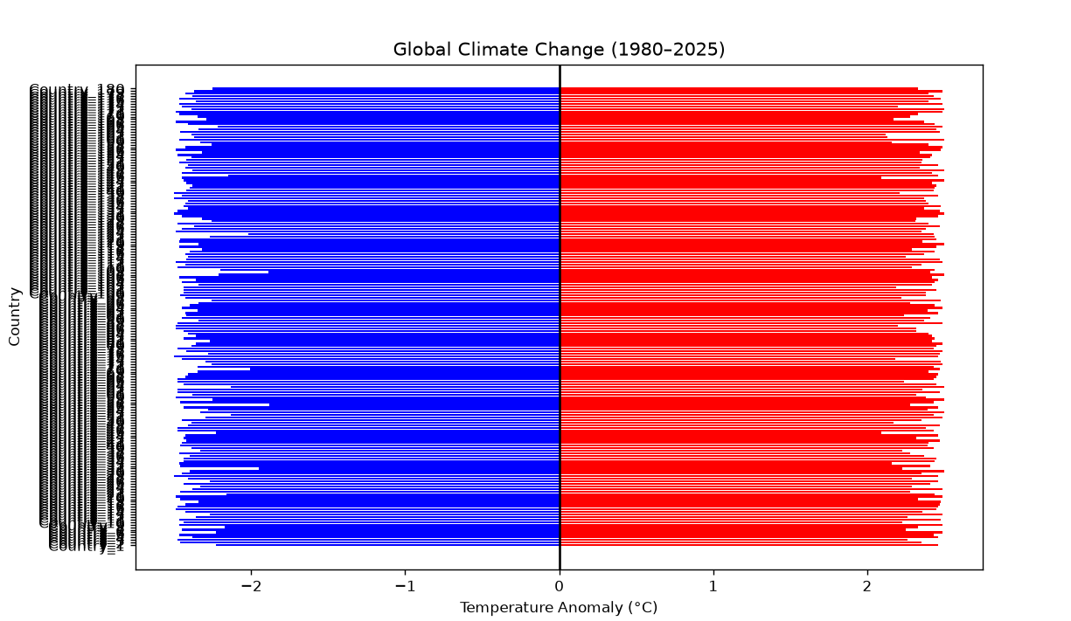

Scenario 6: E-Commerce Sales Analytics
Python code:
import pandas as pd
import matplotlib.pyplot as plt

# Read dataset
df = pd.read_csv("ecommerce_sales.csv")

# Sum sales by category
sales = df.groupby("Category")["Total_Sales"].sum()

# Plot
plt.figure(figsize=(8,5))
plt.bar(sales.index, sales.values)

plt.title("Total Sales by Category")
plt.xlabel("Category")
plt.ylabel("Total Sales")
plt.xticks(rotation=45)

plt.tight_layout()
plt.show()

Output:
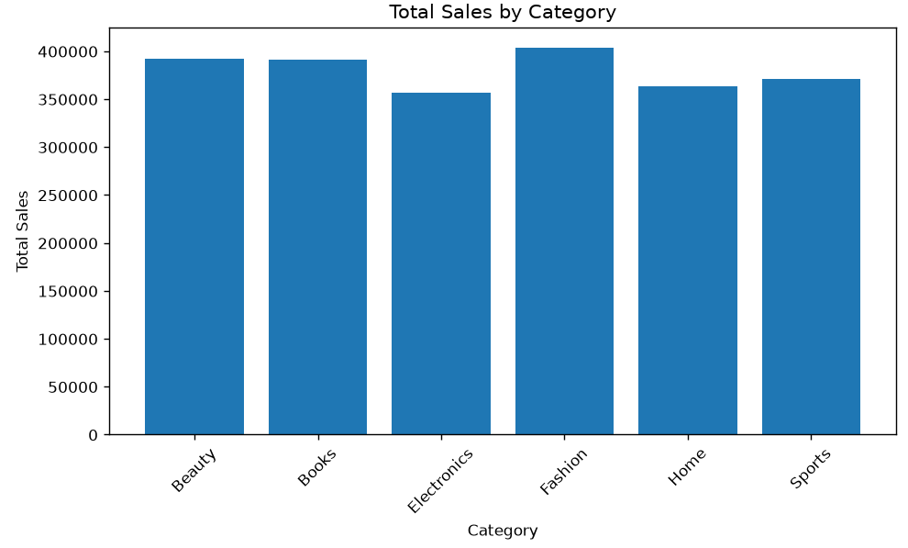

Scenario 7: Satellite Image Vegetation Analysis
Python code:
import pandas as pd
import matplotlib.pyplot as plt

# Read dataset
df = pd.read_csv("satellite_ndvi.csv")

# Classify NDVI values
colors = []
for x in df["NDVI"]:
if x > 0.5:
colors.append("green")
elif x >= 0:
colors.append("yellow")
else:
colors.append("blue")

# Plot
plt.figure(figsize=(8,5))
plt.scatter(range(len(df)), df["NDVI"], c=colors)

plt.title("Satellite NDVI Vegetation Analysis")
plt.xlabel("Sample")
plt.ylabel("NDVI Value")
plt.grid(True)

plt.show()

Output:
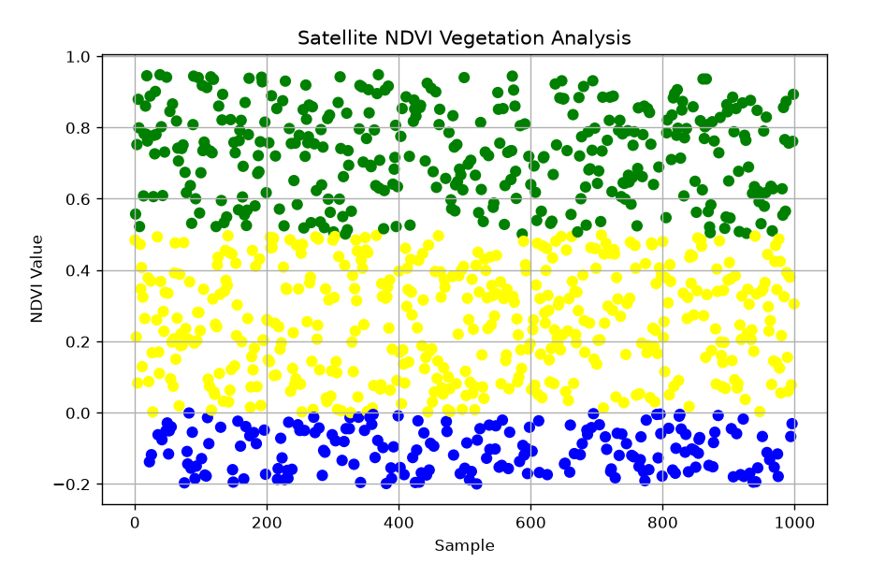

Scenario 8: Cryptocurrency Market Volatility
Python code:
import pandas as pd
import matplotlib.pyplot as plt

# Read dataset
df = pd.read_csv("cryptocurrency_market.csv")

# Plot each cryptocurrency
for crypto in df["Cryptocurrency"].unique():
data = df[df["Cryptocurrency"] == crypto]
plt.plot(data["Date"], data["Close_Price_USD"], label=crypto)

# Logarithmic scale
plt.yscale("log")

plt.title("Cryptocurrency Market Volatility")
plt.xlabel("Date")
plt.ylabel("Closing Price (USD)")
plt.legend()
plt.xticks(rotation=45)
plt.tight_layout()

plt.show()

Output:
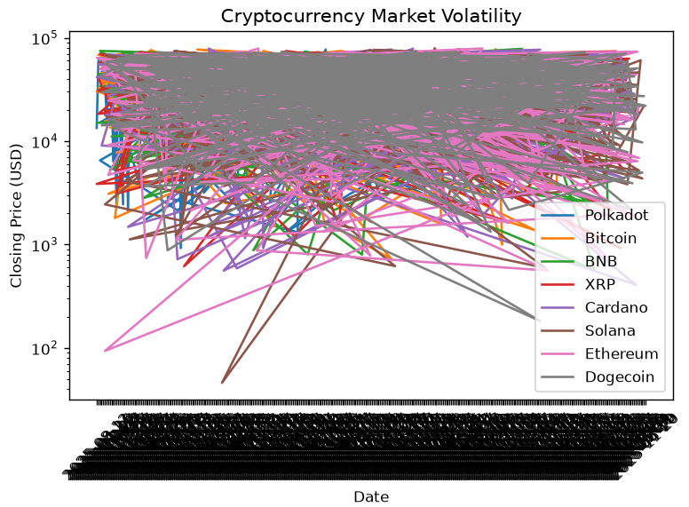

Scenario 9: Marathon Runner Performance Analysis
Python code:
import pandas as pd
import matplotlib.pyplot as plt

# Read dataset
df = pd.read_csv("marathon_runner.csv")

# Scatter Plot
plt.figure(figsize=(8,5))

plt.scatter(
df["Distance_km"],
df["Average_Pace_min_per_km"],
c=df["Average_Heart_Rate_bpm"],
s=60
)

plt.colorbar(label="Average Heart Rate (BPM)")
plt.title("Marathon Runner Performance Analysis")
plt.xlabel("Distance Covered (km)")
plt.ylabel("Average Pace (min/km)")
plt.grid(True)

plt.show()

Output:
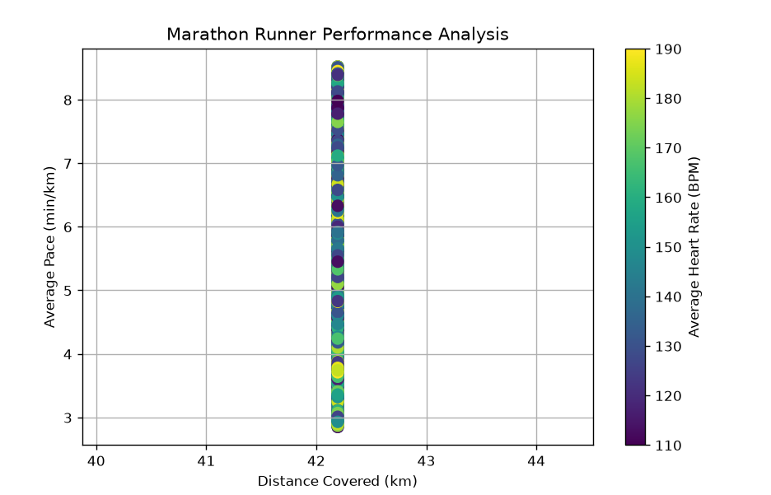

Scenario 10: COVID-19 Vaccination Campaign Dashboard
Python code:
import pandas as pd
import matplotlib.pyplot as plt

# Read CSV
df = pd.read_csv("covid_vaccination.csv")

# Convert Date column
df["Date"] = pd.to_datetime(df["Date"])

# Group by Date
daily = df.groupby("Date")[["People_Fully_Vaccinated",
"People_Partially_Vaccinated"]].sum()

# Plot
plt.figure(figsize=(12,6))

plt.plot(daily.index,
daily["People_Fully_Vaccinated"],
marker='o',
linewidth=2,
label="Fully Vaccinated")

plt.plot(daily.index,
daily["People_Partially_Vaccinated"],
marker='s',
linewidth=2,
label="Partially Vaccinated")

plt.title("COVID-19 Vaccination Campaign Dashboard")
plt.xlabel("Date")
plt.ylabel("People Vaccinated")
plt.legend()
plt.grid(True)

plt.xticks(rotation=45)
plt.tight_layout()

plt.show()

Output:
